SWINBURNE VIETNAM
HO CHI MINH CAMPUS


COS30018 - COS30018-Intelligent Systems
Week 9: Report

INSTRUCTOR: MR. KY TRUNG PHAM
STUDENT NAME: LÊ TIẾN DŨNG-SWS00683

HO CHI MINH CITY – MAR-2026

Contents
1. What is the "Ensemble" approach? How does combining a statistical model like ARIMA with a Deep Learning model like LSTM improve the reliability of the prediction? 3
2. Explain how you integrated ARIMA/SARIMA into your Python workflow. How do these traditional models handle "Seasonality" in stock data? 3
3. How do you resolve conflicts if the LSTM predicts a "Price Up" movement while the ARIMA model predicts a "Price Down" movement? 5

1. What is the "Ensemble" approach? How does combining a statistical model like ARIMA with a Deep Learning model like LSTM improve the reliability of the prediction?

An ensemble approach combines predictions from multiple models to improve robustness and reduce the risk of relying on a single model that may fail under certain market conditions. In this project, I combined a traditional statistical model (SARIMA) with a deep learning model (LSTM):
- LSTM is suitable for learning non-linear patterns and can use multiple features (Close, Volume, High, Low) to capture market behavior.
- SARIMA is a classical time-series model that provides a stable forecast based on statistical structure. It is often less sensitive to noise and can help as a secondary viewpoint.
By combining these two models, the system can become more reliable because each model contributes different strengths. The ensemble prediction is produced using a weighted average of the LSTM and SARIMA forecasts.
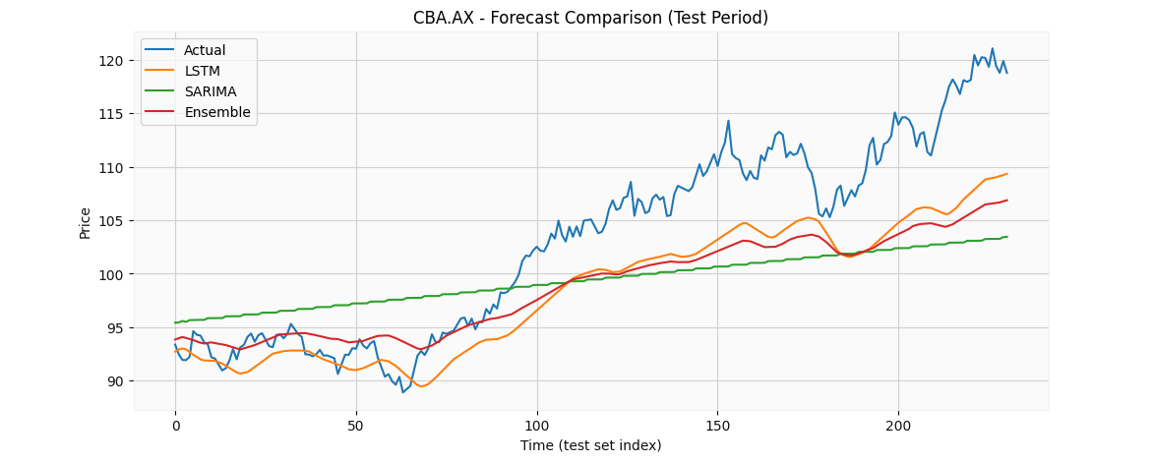
Figure 1: “Week 9 – CBA.AX Forecast Comparison (Actual vs LSTM vs SARIMA vs Ensemble)”

2. Explain how you integrated ARIMA/SARIMA into your Python workflow. How do these traditional models handle "Seasonality" in stock data?

To integrate SARIMA into my Python workflow, I used the statsmodels library (SARIMAX implementation). The main steps were:
- Extract the training Close price series from the dataset.
- Fit a SARIMA model on the training series using:
- order = (1,1,1)
- seasonal_order = (1,1,1,5)
- Forecast the entire test period (same length as the test set).
- Evaluate SARIMA predictions using the same regression metrics as LSTM (MAE, MSE, RMSE).
- Combine SARIMA predictions with LSTM predictions to form the ensemble forecast.
Seasonality handling:
SARIMA extends ARIMA by including seasonal parameters (P, D, Q, m). The m value represents the seasonal cycle length. In this experiment, I used m = 5 to represent a weekly trading cycle (5 trading days). This allows SARIMA to model repeating weekly patterns when they exist in the data.

Runtime results (efficiency of traditional model integration):
- SARIMA fit time: 0.554 seconds
- SARIMA forecast time: 0.005 seconds

This shows SARIMA can be integrated efficiently into the workflow with minimal computation cost compared to deep learning training.

Evaluation Results: LSTM vs SARIMA vs Ensemble (CBA.AX):
I evaluated all predictions on the same test period using MAE, MSE, and RMSE (lower values indicate better performance).
Model | Train time (sec) | MAE | MSE | RMSE
LSTM | 87.66 | 4.7703 | 32.7204 | 5.7202
SARIMA | 0.5538 | 6.5959 | 59.4250 | 7.7088
Ensemble (wLSTM=0.58, wSARIMA=0.42) | ~0.56* | 4.9872 | 40.0407 | 6.3278
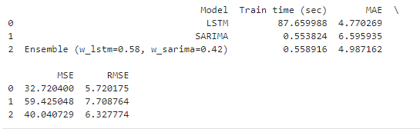
Figure 2: “Week 9 – Test Performance Table (MAE/MSE/RMSE): LSTM vs SARIMA vs Ensemble”
*The ensemble computation itself is almost instantaneous because it is only a weighted combination. Total system runtime includes LSTM training time plus SARIMA fit/forecast time.
Discussion:
- SARIMA was the fastest model to train but produced the largest prediction errors in this test period.
- LSTM achieved the best accuracy (lowest MAE/MSE/RMSE).
- The ensemble produced stable predictions but did not outperform LSTM in this experiment (ensemble MAE 4.99 > LSTM MAE 4.77). This outcome is still valid: ensemble methods improve robustness, but accuracy improvement depends on model selection and weight tuning.

3. How do you resolve conflicts if the LSTM predicts a "Price Up" movement while the ARIMA model predicts a "Price Down" movement?
To handle situations where the LSTM and SARIMA predictions disagree in direction, I implemented a direction-based conflict resolution rule:
- Convert each model’s next-day prediction into a direction:
  - UP if predicted next price > last close
  - DOWN otherwise
- If both models agree, follow that direction.
- If they conflict, trust the model with better recent performance (lower MAE).

Observed conflict example (next-day forecast):
- Last close: 118.7782
- LSTM next prediction: 109.3372 → DOWN
- SARIMA next prediction: 118.9694 → UP
- Ensemble next prediction: 113.3797 → DOWN

Because LSTM had lower test MAE (4.77) compared to SARIMA (6.60), the final decision was:

Final decision: DOWN
Reason: conflict → trust the model with lower MAE (LSTM).

This rule ensures the decision process is consistent, transparent, and based on measured model performance.
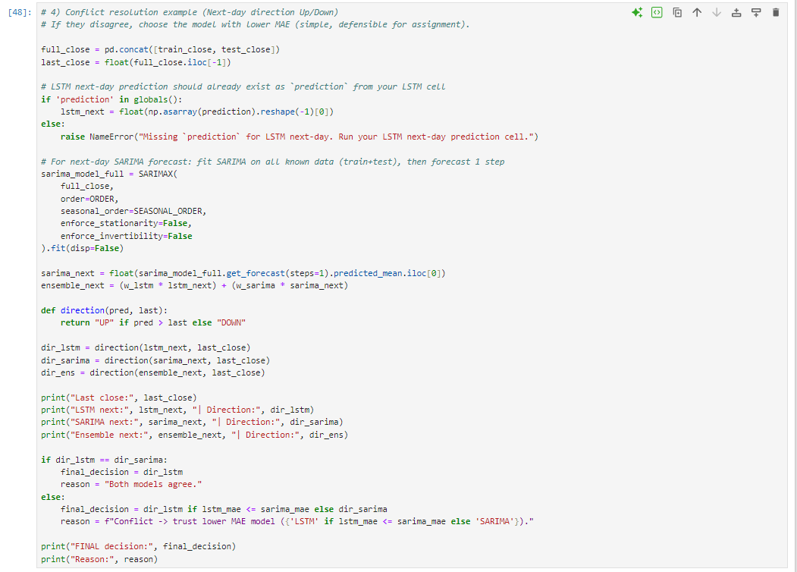
Figure 9.3: “Week 9 – Direction Conflict Resolution (LSTM vs SARIMA, Performance-Based Rule)”

